A Mini Project Report
on
Online Pet Shop Management System
by
Shalaka Thorat ( )
Prabhav Karve ( )
Prasad Mistary ( )
Manoj Kumawat ( )

Under the guidance of
Prof. Sameer Mamadapure

Department of Information Technology
Hope Foundation's
International Institute Information Technology, Pune
SAVITRIBAI PHULE PUNE UNIVERSITY
2019-2020

Department of Information Technology
International Institute Information Technology, Pune

Date:-
CERTIFICATE

This is to certify that,
Shalaka Thorat ( )
Prabhav Karve ( )
Prasad Mistary ( )
Manoj Kumawat ( )

of class TE-IT; have successfully completed their mini project work on “Online Pet Shop Management System’’ at International Institute Information Technology , Pune
in the partial fulfillment of the Graduate Degree course in T.E at the department of Information Technology, in the academic Year 2019-2020 Semester – I as prescribed by the Savitribai Phule Pune University.

Prof.Sameer Mamadapure Prof. Sarang Saoji
Guide Head of the Department
(Department of Information Technology)

Acknowledgements

I am heartly thankful to our Guide Prof. Sameer Mamadapure and our HOD Information Technology Department, Prof . Sarang Saoji for giving me this opportunity to develop the project. I sincerely thank our department for academic advancement it has provided to us during semester 5.
I would like to thank my team members for their huge support, cooperation, innumerable discussions on many technicalities and friendly tips. I am thankful to my parents too for encouraging me and giving me thoughtful views regarding the content and design of the project.

Shalaka Thorat ( )
Prabhav Karve ( )
Prasad Mistary ( )
Manoj Kumawat ( )

I
Contents

Sr. No. | Topic |  | Page No.
 | Acknowledgement |  | I
 | Contents |  | II
 | List of Tables |  | III
 | List of Forms |  | IV
 | Acronyms |  | V
 | Abstract |  | VI
Chapter-1 | Introduction |  | 1
 | 1.1 | Motivation | 1
 | 1.2 | Problem Statement | 2
 | 1.3 | Framework of the proposed work in project | 3
Chapter-2 | Literature Review |  | 5
 | 2.1 | Introduction | 5
 | 2.2 | Existing methodologies | 6
 | 2.3 | Proposed methodologies | 7
Chapter-3 | Software Requirement Specification |  | 8
 | 3.1 | Hardware Requirements | 8
 | 3.2 | Software Requirements | 9
Chapter-4 | Assumptions |  | 10
Chapter-5 | Entity-Relationship Diagram |  | 11
Chapter-6 | Tables |  | 12
Chapter-7 | Forms |  | 15
Chapter-8 | Features |  | 19
Chapter-9 | Conclusion |  | 20
 | References |  | 21

II
List of Tables

Table No. | Title | Page No.
6.1 | User Table | 12
6.2 | Paw Cart Table | 12
6.3 | Paw Cart Orders Table | 12
6.4 | Paw Cart Order-Items Table | 13
6.5 | Available Pets Table | 13
6.6 | Adoption Table | 13
6.7 | Vet Appointment Table | 14

III
List of Forms

Figure No. | Title | Page No.
7.1 | Sign Up Form | 15
7.2 | Login Form | 15
7.3 | Cat Adoption Form | 16
7.4 | Dog Adoption Form | 16
7.5 | Place Paw Cart Order Form | 17
7.6 | Confirm Paw Cart Order Form | 17
7.7 | Vet Appointment Form | 18

IV
Acronyms

uid | User ID For Users
phonen | Phone Number
icode | Item Code For Paw Cart Items
availadopt | Whether pet is available for Adoption/ Adopted/ In Adoption Process
orderno | Order Number
orderdate | Date Time when Order was placed
addr | Address
qty | Quantity
petagem | Pet Age in Months

V
Abstract

This project is compulsory as it is part of the college syllabus and as a core subject. The reason behind this system is that I’ve developed a new system that can help to reduce the paper work of a pet shop. So I decided to develop a Pet shop Management System as my DBMS project.
Scope:
I am responsible to back-end part of the system, allowing administrator to do all the maintenance in the system, allowing all users to register and use our system and design the basic function to reduce the work-load of the users.
Methodology:
PHP is great for developing systems. Most of the back-end class is built by PHP. For the database that used to store data of the system, I use MySQL Server and as for the connection I use PHP PDO connection to bridge-up PHP pages and MySQL server for data retrieving.
Assessment criteria used:
I have to keep the layout as simple and as direct as possible so users can easily understand the purpose of my system.
Development phases:
Firstly, I discussed the project scope with the guide. Next, I accordingly created strategic plan for the project. I discussed with the team what modules to include in the project. We all split up the project work and built individual modules. After all modules were done we integrated them and made the entire system work properly. Then we kept our focus on the use-centric design of the website and implemented accordingly.
Results:
Although the result isn’t as perfect as I planned, but the overall outcome is much satisfied as most of the features which I planned have been successfully implemented into the system.
VI
Chapter 1
Introduction
  - Motivation
There are so many cases we hear when animals die unnecessarily, or many a times people bring pet/s to their homes and when they cannot take proper care, they leave them on road and many mishaps happen to them.
This actually encouraged us to create a pet website where we will be able to look after these pets, cure them and give them new homes where they can live peacefully.
Also for pampered pets, there is online pet shop (Paw Cart) and schedule vet-appointments easily. Through our activities, we want to educate and inspire the urban community to peacefully co-exist with animals on our streets.

1
Chapter 1
Introduction
  - Problem Statement

Design an Online Pet Shop Management System which will have 3 modules described as follows:
- Vet Appointment: which will schedule vet-appointments for pets and store the entries in the table called 'appointment'.
- Adoption: in which users will be able to see pets available for adoption (information retrieved from database called 'avpets') and which will allow users to fill the cat/dog form and these requests will be stored in a different table called 'adopt' .
- Paw Cart: which will display menu of food items, toys and pet treats available for shopping. This information will be retrieved from a table called 'foodtoys'. When user places an order, then that entry must be made in database called 'orders' and listing of individual items in the order will be mapped according to order number in table called 'orderitems'.
The user must first create an account and login before accessing these modules. The information related to user accounts will be stored in table called 'user'.

2
Chapter 1
Introduction
  - Framework of the proposed work in project
    - Creating Required Database and Tables
Firstly, database with all the tables including proper schema and primary, foreign keys is created.

    - Creating Login/Signup Page
Next, Login/Signup Page layout is created and proper validation for each element in login/signup form is made using PHP.

    - Creating Home Page of Website
A detailed design of the homepage is created with application of CSS and HTML and various modules were linked to it.

    - Creating Vet-Appointment Module
A proper PHP validated form for every input field was made and thank you page when appointment is scheduled is created.

    - Creating Adoption Module
In this module, there are links for filling Cat Adoption and Dog Adoption Forms made with PHP validation. And another link is there which shows pets available for adoption in which values are retrieved from database and displayed in table format.

    - Creating PawCart Module
It displays a menu showing different items for shopping, values of which are retrieved from database. It shows items which are out of stock in grey field. There are 2 forms, one for placing an order where user has to enter item codes and quantity, and another for confirming order where order summary is shown and user has to enter address and mobile number and confirm the order. Then a thank you page will be shown.
3
Gantt Chart:

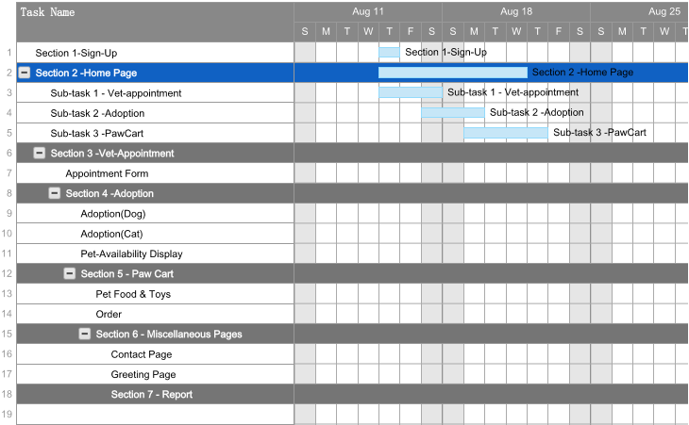
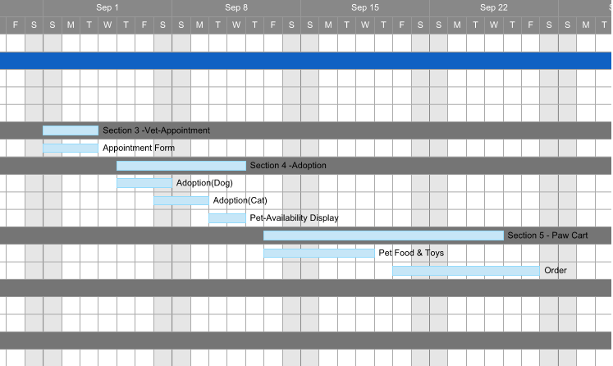
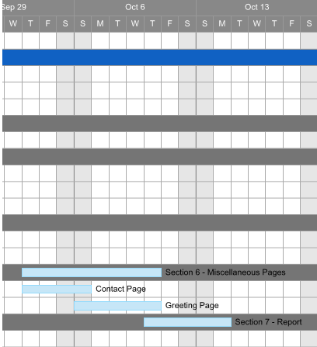

4
Chapter 2
Literature Review
2.1 Introduction
This chapter is organised as follows.
Section 2.2 describes the Existing Methodology as that the system is only handled and controlled manually. It is very much time consuming and not user-friendly. The transactions are running offline and the proper reports are not generated.
The Section 2.3 describes the Proposed Methodology including Enhancement, Automation, Accuracy, User-Friendliness, Availability, Maintenance, in The New E-System.

5
Chapter 2
Literature Review
2.2 Existing Methodologies
- The Existing system only provides test-based interface, which is not as user-friendly as Graphical User Interface.

- Since the system is implemented in manual, so the response is very slow.

- The transactions are executed in offline mode, hence on-line data capture and modification is not possible.

- Offline reports cannot be generated due to batch mode execution.
Hence, there is need of reformation of the system with more advantages and flexibility. The Pet Shop Management System eliminates most of the limitations of the existing software. It has the following objectives.

6
Chapter 2
Literature Review
2.3 Proposed Methodologies
2.3.1 Enhancement
The main objective of Pet Shop Management System is to enhance and upgrade the existing system by increasing its efficiency and effectiveness. The software improves the working methods by replacing the existing manual system with the computer-based system.

2.3.2 Automation
The pet Shop Management System automates each and every activity of the manual system and increases its throughput. Thus the response time of the system is very less and it works very fast.

2.3.3 Accuracy
The pet Shop Management System provides the uses a quick response with very accurate information regarding the users etc. Any details or system in an accurate manner, as and when required.

2.3.4 User-Friendly
The software pet Shop Management System has a very user-friendly interface. Thus the users will feel very easy to work on it. The software provides accuracy along with a pleasant interface. Make the present manual system more interactive, speedy and user friendly.

2.3.5 Availability
The transaction reports of the system can be retried as and when required. Thus, there is no delay in the availability of any information, whatever needed, can be captured very quickly and easily.

2.3.6 Maintenance Cost
Reduce the cost of maintenance.

2.3.7 Security
This is very important aspect of the design and should cover areas of hardware reliability, fall back procedures, physical security of data and provision for detection of fraud and abuse.
System design involves first logical design and then physical construction of the system. The logical design describes the structure and characteristics of features, like the outputs, inputs, files, database and procedures. The physical construction, which follows the logical design, produces actual program software, files and a working system.
7
Chapter 3
Software Requirement Specification
3.1 Hardware Requirements
- Processor : X86 Compatible processor with 1.7 GHz Clock speed

- RAM : 512 MB or more

- Hard disk : 20 GB or more

- Keyboard : 104 Keys

- Monitor : VGA/SVGA

- Mouse : 2 buttons/ 3 buttons

8
Chapter 3
Software Requirement Specification
3.2 Software Requirements
- Operating System : Windows 10

- Front end : HTML, CSS, JavaScript, PHP

- Back end : MySQL

9
Chapter 4
Assumptions
- Firstly, the user has to create an account by filling the necessary details and then user will be redirected to the Login Page. Login in the account and Surf the site according your need.

- After login you are directed to the Home Page where three modules will be show-cased.

- It is assumed that user should enter the Itemcode and Quantity to place his/her order on Paw Cart.

- While placing an order on PawCart, user has to pay through Cash on Delivery (COD) Payment Method only, other methods are not provided.

10
Chapter 5
E-R Diagram

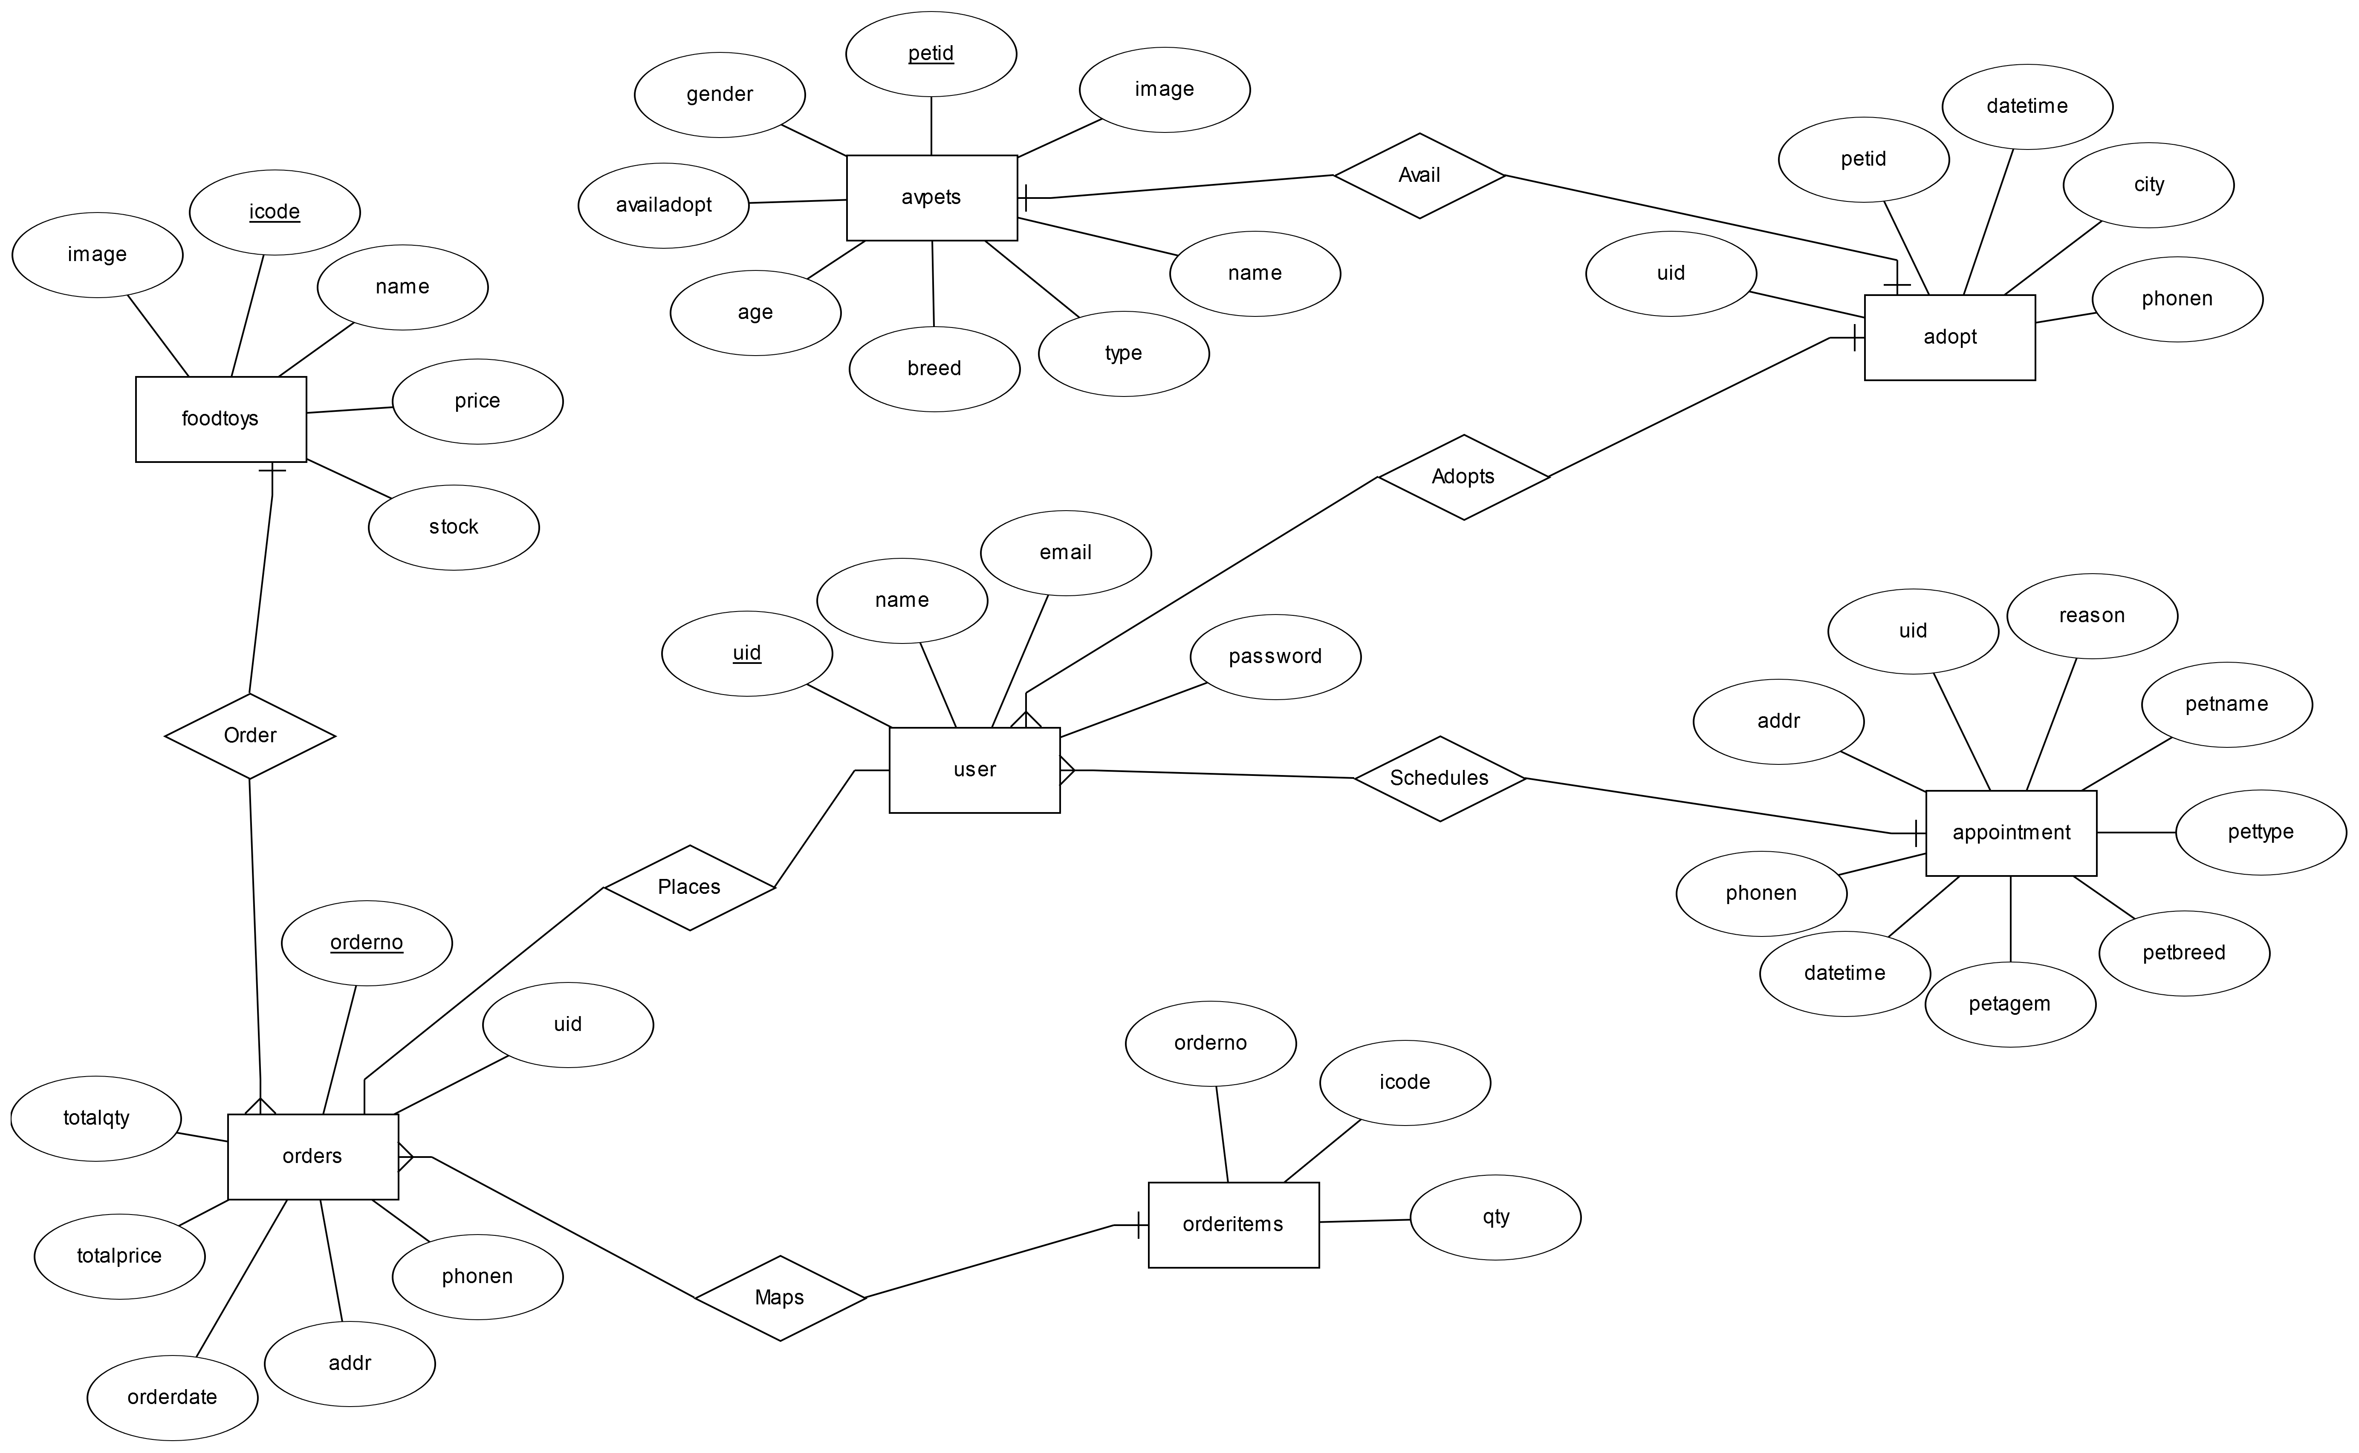

11
Chapter 6
Tables
6.1 User Table
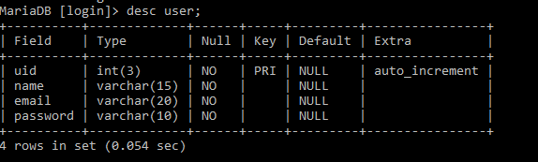

6.2 Paw Cart Table
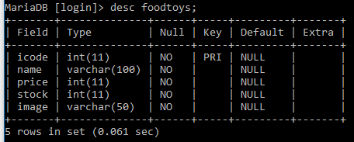

6.3 Paw Cart Orders Table
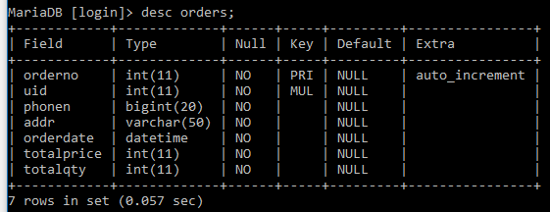
12
Chapter 6
Tables
6.4 Paw Cart Order-Items Table
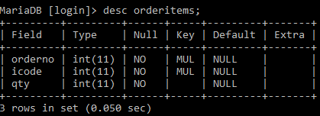

6.5 Available Pets Table
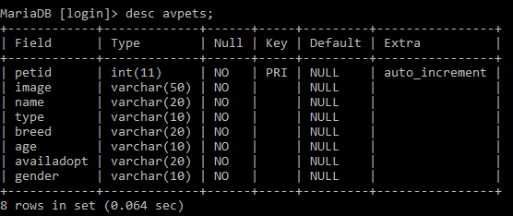

6.6 Adoption Table
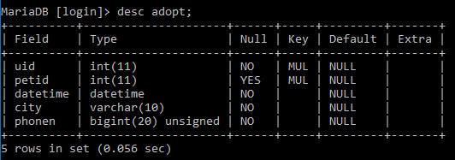
13
Chapter 6
Tables
6.7 Vet Appointment Table
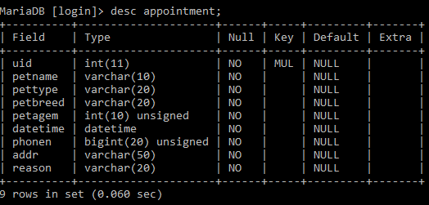

14
Chapter 7
Forms
7.1 Sign Up Form
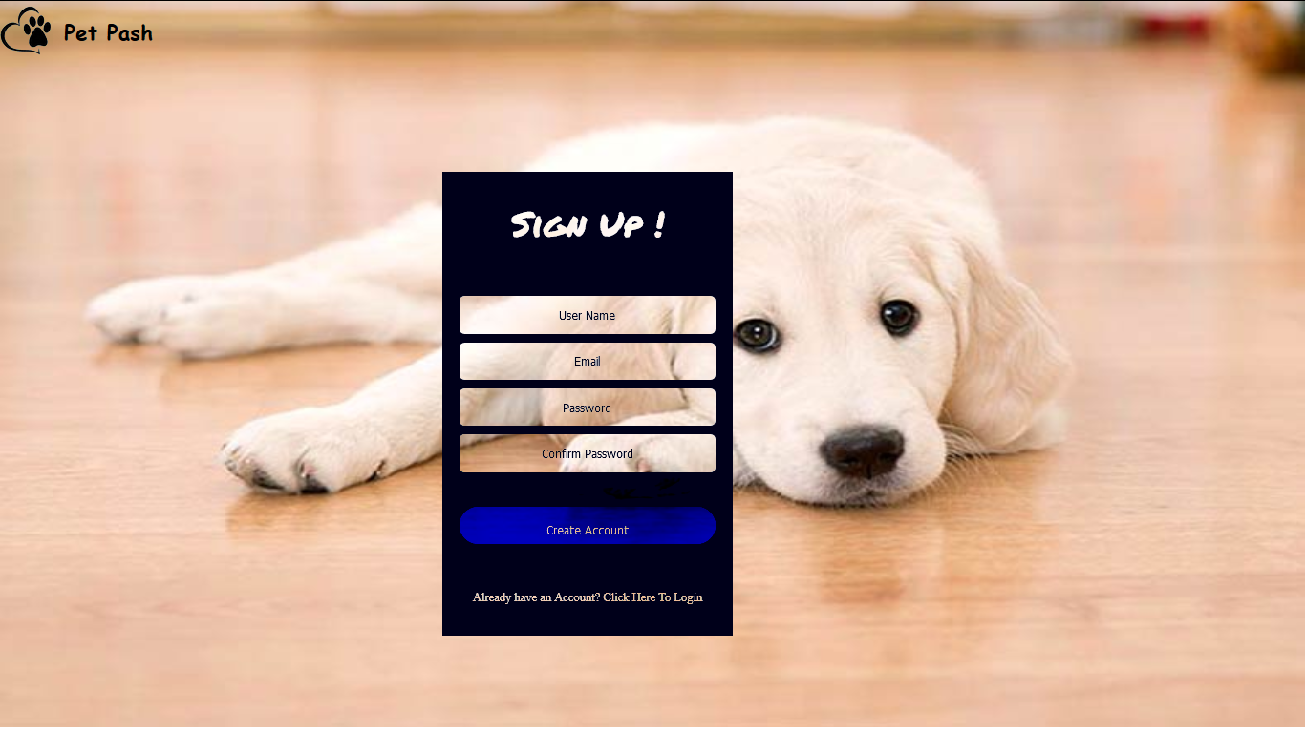

7.2 Login Form
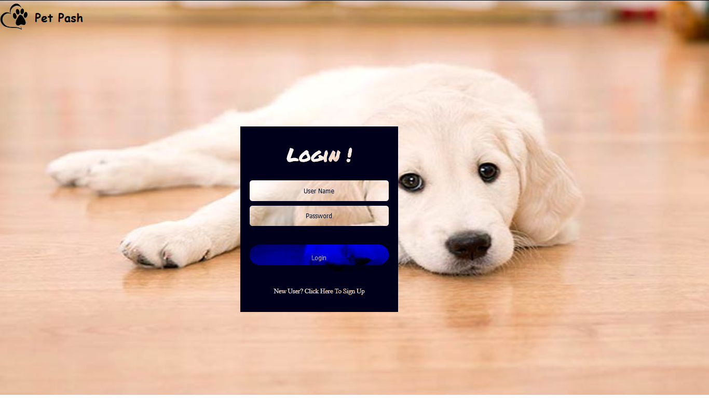

15
Chapter 7
Forms
7.3 Cat Adoption Form
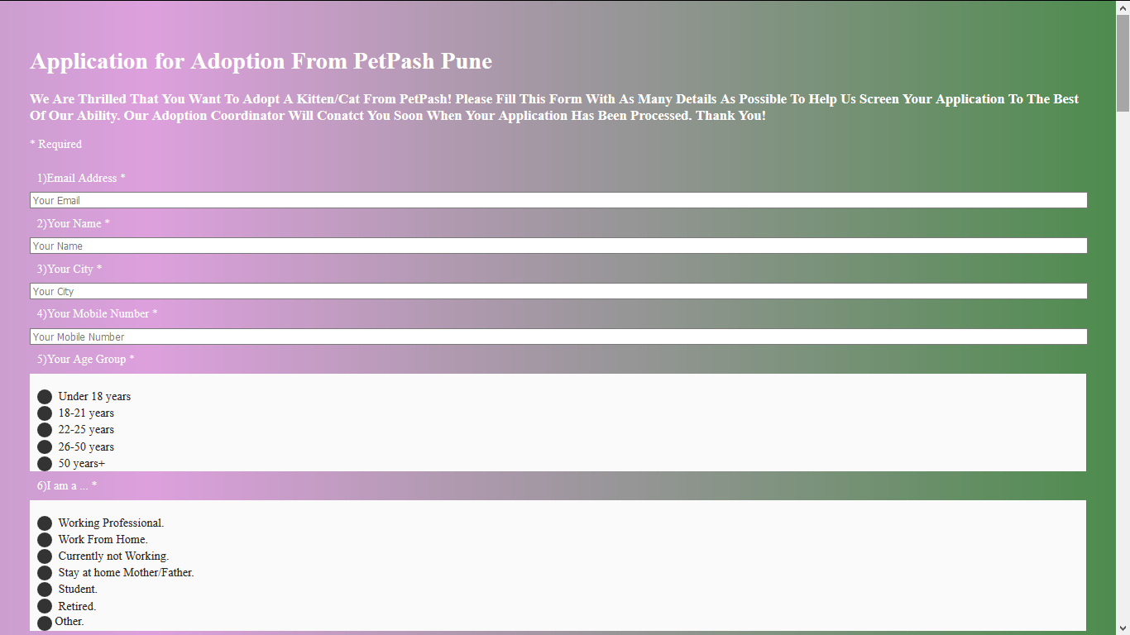

7.4 Dog Adoption Form
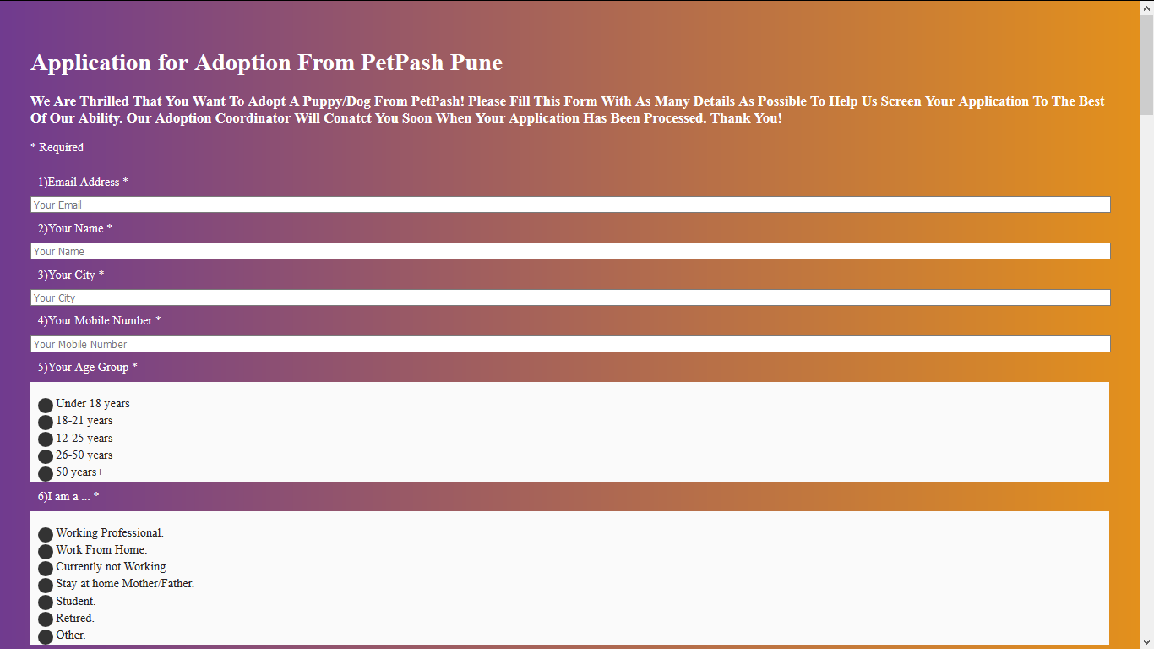

16
Chapter 7
Forms
7.5 Place Paw Cart Order Form
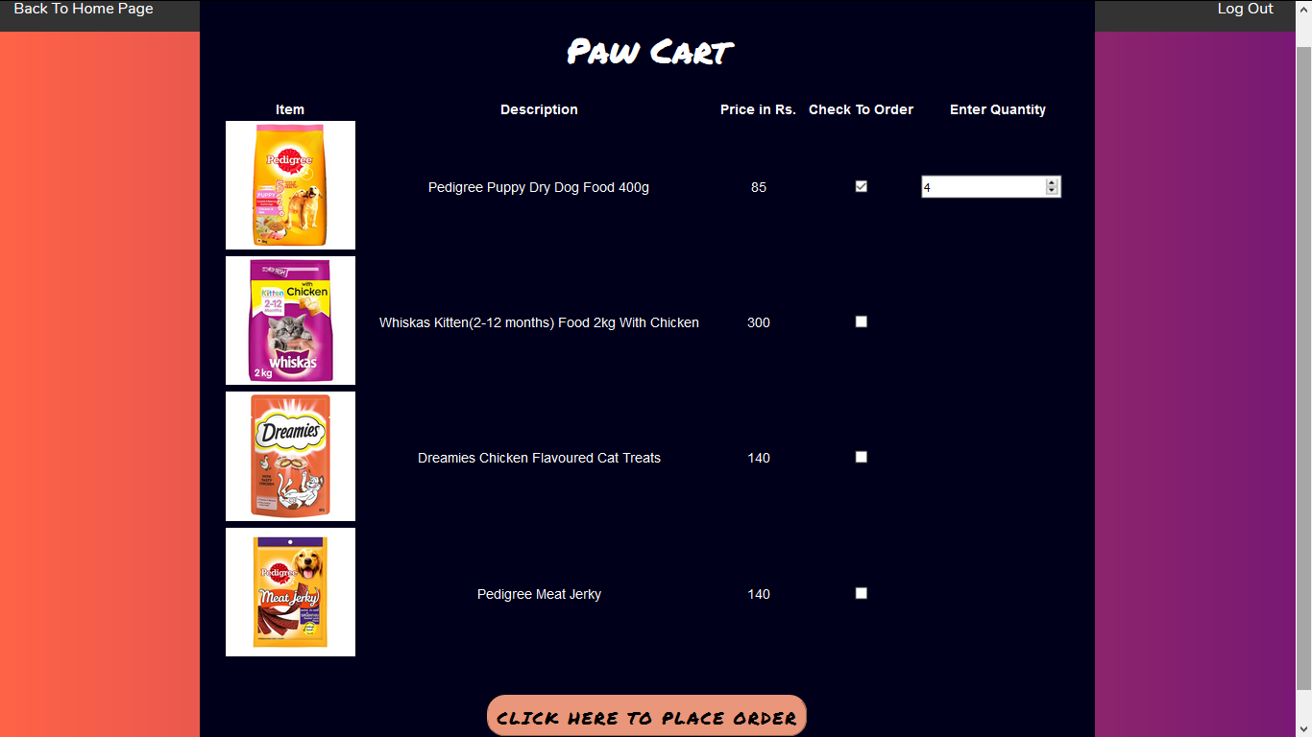

7.6 Confirm Paw Cart Order Form
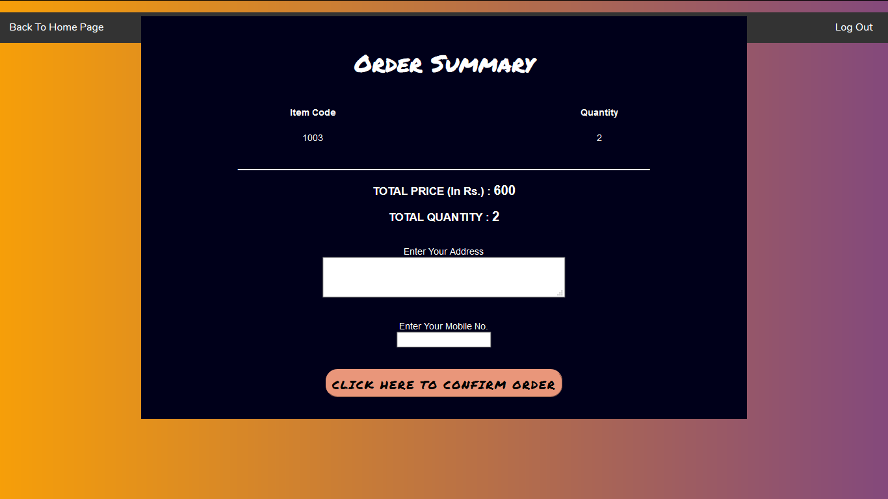
17
Chapter 7
Forms
7.7 Vet Appointment Form
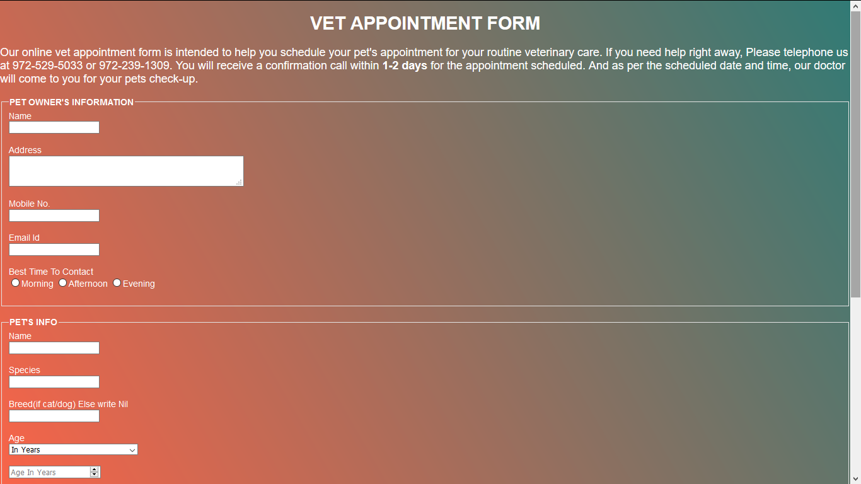

18
Chapter 8
Features
- The Questions in the adoption form of cat and dog are arrange in such a way that the User will be given appropriate pet for adoption which will suit his/her choices and opinions. Also the pet will be comfortable with its master.

- The design of the site is user centric and designed in such a way that it will be easy to use and fascinating for users every time they visit the website through the different colour transitions on every page in the background.

- In the Paw Cart when a particular item is out of stock, that specific entry will be displayed in grey colour.

- Even if user enters item code for the item out of stock, or a negative value, proper message gets displayed.

- When the user inputs any wrong entry, proper message gets displayed and the form won’t get submitted until you correct the mistake as per the validation.

- The user will be able to view his/her past orders, adoptions and appointments made so far using the 'View Past Orders/Appointments' link.

- Each input field of all the forms has been properly validated so that any inconvenience won't take place.

- The information that is less important and not highly personal in Vet Appointment Form and Cat/Dog Adoption Forms has been saved respective csv (comma separated values) files. Thus there is no overloading of values in the database. Also user's private information is not exposed.

- Whenever user places an order, it gets stored in 'orders' table. Also each item code and quantity respective to that order number gets stored in 'orderitems' table. These values could have been accommodated in 'orders' table, but other fields like user id, order date, address etc. would have been unnecessarily repeated. Thus there is direct mapping of order number and item code, quantity in 'orderitems' table. So it can be said to be in normalised form.

19
Chapter 9
Conclusion
- The Online Pet Shop Management is successfully done to make scheduling of vet-appointments and shopping easier. Also it helps pets for easy re-homing.
- The project is completed that follow the Incremental Model.

20
References

- https://erdplus.com/

- https://www.php.net

- https://www.resqct.org

- https://www.stackoverflow.com

- https://www.w3schools.com

21

